**1** Complete the sentences on cells using words from the list below.

**a)** A ……… is a male gamete.

**b)** Gametes contain the ……… number of chromosomes.

**c)** The nucleus contains the ………, which is the genetic material of the cell.

**d)** An ……… is a variant of a gene.

**e)** ……… cells contain a nucleus. (5)

DNA   eukaryotic   sperm   allele   haploid

**2** A horse has 64 chromosomes in every cell in its body. A donkey has 62 chromosomes.

**a)** How many chromosomes are there in:

**i)** a donkey egg cell?

**ii)** a cell from the muscle of a horse?

**iii)** a fertilized donkey egg?

**iv)** a horse sperm cell?

**v)** a diploid cell from a donkey? (5)

**3** Mitosis is the name of a type of cell division. The diagrams below show the stages of mitosis but in the wrong order.

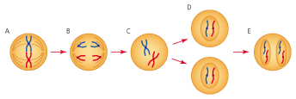

**a)** Put the diagrams in the correct order in the table. The first one has been done for you.

|  |  |  |  |  |
| --- | --- | --- | --- | --- |
| C |  |  |  |  |

(2)

**b)** Which stage shows interphase? (1)

**c)** What happens to the cell during interphase? (2)

**d)** Which diagram shows the stage just before cytokinesis? (1)

**e)** What is cytokinesis? (2)

**f)** This diagram shows the start of mitosis.

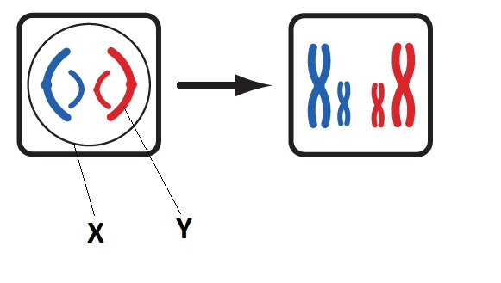

**i)** Label X and Y on the diagram. (2)

**ii)** What has happened to X and Y in the second stage? (2)

**iii)** Why are the structures labelled Y colour coded? (2)

**g)** Why is mitosis so important in living organisms? Give three reasons. (3)

**4** Cells that are produced by mitosis become specialised. This means that they are adapted to carry out specific jobs. Specialised cells usually change in some way so that they are able to carry out their job more easily. A newly formed cell is called a stem cell. This cell has not yet specialised. Both plants and animals have stem cells.

**a)** Where in a plant does mitosis take place (two places)? (2)

**b)** What is the name given to the regions of a plant which are undergoing mitosis and producing plant stem cells? (1)

**c)** What term is used to describe the changes a cell goes through to become specialised. (1)

**d)** Stem cells in humans are found in an embryo. What is an embryo? (2)

**e)** Embryonic stem cells are totipotent. What does totipotent mean? (2)

**f)** Explain why human stem cells could be useful in medicine. (4)

**5** The diagrams below show how a cutting from a shoot can be obtained.

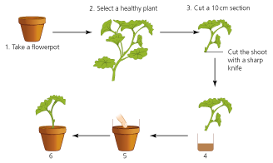

**a)** What should be placed into the flowerpot? (2)

**b)** The end of the cutting is dipped into a compound in 4. What is this compound and why is it used? (2)

**c)** Suggest what is happening in stage 5. (2)

**d)** Copy diagram 6 and draw what you would see if the cutting was left for 6 weeks. (1)

**e)** The advantages and disadvantages of growing plants from cuttings. (4)

TOTAL = 48

**1** **a)** sperm

**b)** haploid

**c)** DNA

**d)** allele

**e)** eukaryotic (1 mark for each correct answer) (5)

**2** **a)** **i)** 31

**ii)** 64

**iii)** 62

**iv)** 32

**v)** 62

(1 mark for each correct answer) (5)

**3** **a)**

|  |  |  |  |  |
| --- | --- | --- | --- | --- |
| **C** | **A** | **B** | **E** | **D** |

(2 marks = all correct: 1 mark if 2 or 3 correct)

**b)** C (1)

**c)** The cell is preparing for division. Mitochondria and ribosomes are being replicated.

DNA is replicated. (1 mark per point = 2)

**d)** E (1)

**e)** Cytokinesis is the splitting of the cytoplasm. This is when the cell finally splits into two around the nuclei.

(1 mark per point = 2)

**f)** **i)** X = nucleus membrane; Y = chromosome (2)

**ii)** The nucleus membrane disappears. The chromosomes shorten and fatten/The chromosomes copy themselves. (2)

**iii)** Chromosomes are inherited in pairs. One chromosome has come from the mother, the other from the father in a diploid cell. (1 mark per point = 2)

**g)** Mitosis results in genetically identical cells. Mitosis is used in growth and repair so replacement cells are identical to the original. Mitosis is used for asexual reproduction or the production of clones.

(1 mark per point = 3 marks)

**4** **a)** shoot tip; root tip (2)

**b)** meristems (1)

**c)** differentiation (1)

**d)** When an egg is fertilized by a sperm, it forms a zygote. The zygote undergoes mitosis to form a ball of unspecialised cells. These unspecialised cells are called stem cells. An embryo is the ball of undifferentiated (stem) cells.

(1 mark per suitable point = 2)

**e)** Totipotent cells are undifferentiated.

Totipotent cells can develop into any other specialised cell in an adult. (2)

**f)** Treat paralysed patients by making new nerve cells to transplant into a severed spinal cord or damaged brain.

Treat conditions such as diabetes to replace the cells in the body that are no longer working properly.

Replace cells of the choroid in the eye to help patients see again.

Replace injured or defective organs. (2 marks per point = 4)

**5** **a)** moist compost (2)

**b)** hormone rooting powder; stimulates root growth in the cut stem (2)

**c)** A suitable sized hole is made in the compost. The cut end of the shoot can be  
placed in this. (2)

**d)** Drawing should show a network of roots coming from the end of the stem which has been treated. (1)

**e)** Advantages:

* Plants are identical (clones).
* Favourable characteristics can be maintained.
* Many plants can be created from one.
* Cheaper.

Disadvantages:

* If one plant gets a disease, they will all die.
* No variation is possible.

(at least one point from each section; 4 points = 4 marks)

TOTAL = 48